**AJS Routes & Config**

**Routing of View in SPA:**

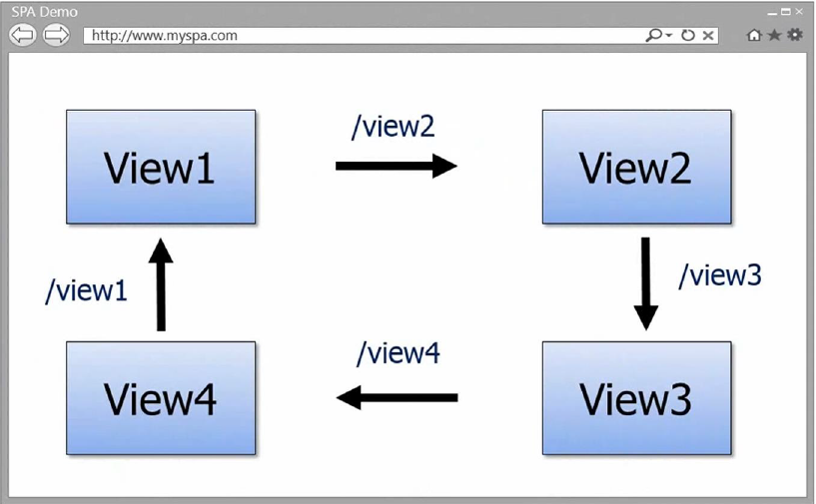

**Sample Implementation:**

Refer to Routes_Config_Views Project